Name ____________________________________________ Date _________________ Period ______

**Topic:** Polynomials: Naming, Adding, Subtracting and Multiplying **Class Website**: msgiwa1.weebly.com

**Add, subtract, or multiply the following polynomials.**

1. 
2. 
3. 
4. 
5. 
6. 
7. 
8. 
9. 
10. 

**Application Problems**: Write your answers in standard form.

1. Write an expression for the **perimeter** and **area** of the following rectangle.

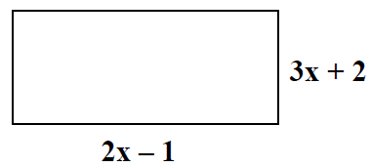

P = ______________ A = ______________

1. Write an expression for the **volume** of the rectangular prism.

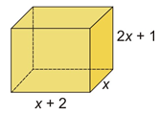

V = __________________

1. Bill’s revenue from giving tennis lessons is represented by **R(x) = (20 + 5x),** and his number of customers is represented by **C(x) = (20 – x).** Find a polynomial, P(x), to represent his profit.

P(x) = ______________________