Name ____________________________________________ Date _________________ Period ______

**Topic:** Review  **Website**: msgiwa1.weebly.com

|  |  |  |  |
| --- | --- | --- | --- |
| Use the following to review for you test. **Work the Practice Problems on a separate sheet of paper.** | | | |
| **What you need to know & be able to do** | **Things to remember** | **Examples** | |
| Find the measure of parts of a chord in a circle | part • part = part • part | **1. Find the value of x** | **2. Find the value of x** |
| Find the measure of segments when two secants intersect a circle. | outside • whole = outside • whole | **3. Find the value of x** | **4. Find the value of x.** |
| Find the measure of segments when a secant and a tangent intersect a circle. | outside • whole = outside • whole | **5. Find the value of x.** | **6. Find the value of x.** |
| Use the properties of congruent tangents | Tangents coming from the same external point are congruent | **7. Find JK.** | **8. Find JM.** |
| Use the properties of congruent chords to find the measures of chords and arcs. | If two chords are congruent then their arcs are congruent | **9. Find the value of KM.** | **10. Find the  if .** |
| Determine if two chords are congruent | Two chords are congruent if they are equidistant from the center of the circle | **11. Are and  congruent?** | **12. Are and  congruent?** |
| Use the properties of congruent chords to find the measure of arcs and segments | Two chords are congruent if and only if they are equidistant from the center of the circle. | **13. Find the measure of YX.** | **14. Find the measure of GF.** |
| Determine if a chord is a diameter. | To be a diameter the chord must be a perpendicular bisector of another chord. | **15. Is  a diameter? Why or why not?** | **16. Is  a diameter? Why or why not?** |
| Use the properties of diameters and perpendicular chords to find the radius of a circle. | Set up the problem so that you can use Pythagorean theorem. | **17. A chord in a circle is 18 cm long and is 5 cm from the center of the circle. How long is the radius of the circle?** | **18. The radius of a circle is 15 inches. A chord is drawn 4 inches from the center of the circle. How long is the chord?** |
| Use properties of tangents to determine if the line is a tangent | You must satisfy the Pythagorean Theorem. | 19. Is  **a tangent? Why or why not?** | 20. Is  **a tangent? Why or why not?** |
| Use properties of tangents to find missing measures. | Pythagorean Theorem | 21. Find the measure of x. | 22. Find the value of x. |
| Find the surface area of spheres. | $$S=4πr^{2}$$ | 23. Find the surface area of the sphere. | 24. What is the diameter of a sphere with a surface area of 44 $π$ ${cm}^{2}$? |
| Find the volume of spheres. | $$V=\frac{4}{3}πr^{3}$$ | 25. A beach ball has a diameter of 8 inches. Find its volume. | 26. Find the volume of the hemisphere. |
| Find the volume of prisms and cylinders. | V=Bh  (where B is the area of the base)  ARectangle= bh  ACircle= πr2  ATriangle= ½ bh  ATrapezoid = ½(b1+b2)h | 27. Find the volume.  4 m  2 m  10 m | 28. Find the volume. 12 in  http://etc.usf.edu/clipart/42200/42221/cylprism_42221_lg.gif  20 in |
| 29. Find the volume.      22cm  25cm  35 cm  21 cm | 30. Find the volume.  http://preview.channel4learning.com/espresso/clipbank/images/students/learning_paths/lp_maths_prisms_ws3_3.jpg |
| Find the volume of pyramids and cones. | V = 1/3 Bh | 31. Find the volume.  http://www.clker.com/cliparts/b/T/d/V/N/B/cone-md.png  15 yd  15.8 yd  5 yd | 32. Find the volume.  http://etc.usf.edu/clipart/43200/43200/quad9_43200_lg.gif  44 in      30 in 28 in |

Tell whether  is tangent to . Explain your reasoning.

1. 2.

25

For each  find the value of *x*. Assume that segments that appear to be tangent are

tangent.

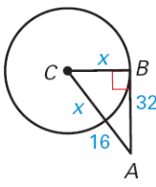

3. 4. 5.

6

x

4

6. 7. 8.

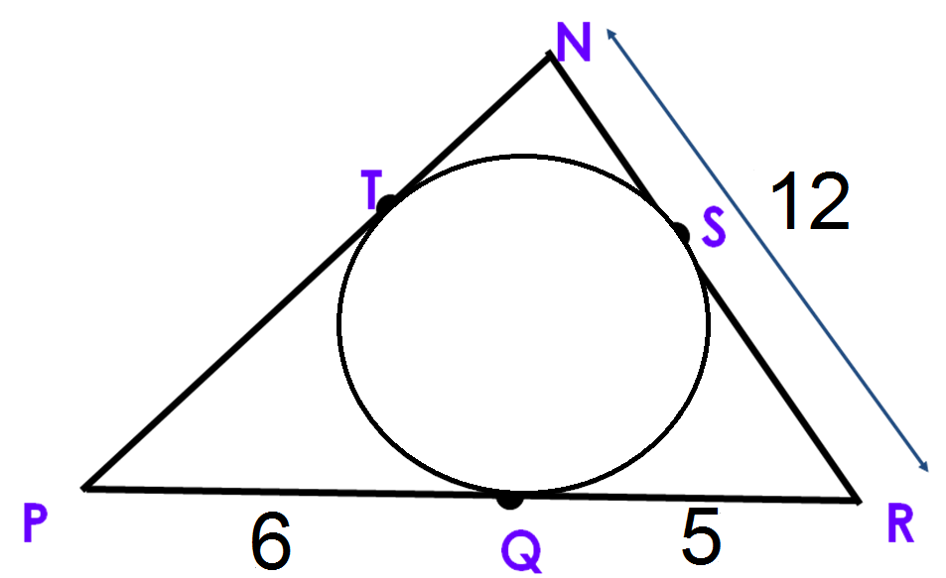

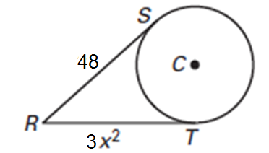

x

Find the value of x.

9. 10. 11.

Find the value of x. Round to the nearest tenth, if necessary.

12. 13. 14.

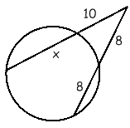

46˚

128˚

x˚

C

D

A

B



15. 16. 17.

**x**

**5**

**13**

Find the volume of the following figures.

18. 19. 20.

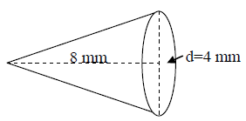

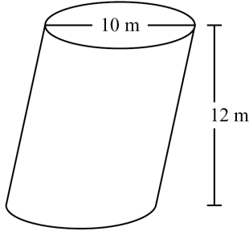 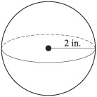

21. 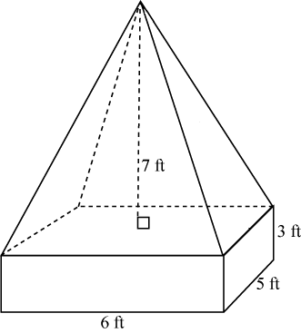 23.

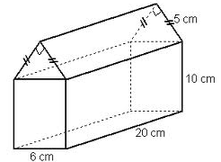

24. A prism has a square base with a width 3 cm. Its volume is 90 cm3. A square pyramid has the same width for its base and the same height as the prism. What is the volume of the pyramid?

25. Find the volume of a triangular prism whose base is an equilateral triangle with sides of 4 m and a height of 10 m.

26. Collin is going to change the oil in his Jeep. He has two funnels. One has a diameter of 6 inches and is 5 inches deep. The other has a diameter of 5 inches but is 7 inches deep. He wants to use the funnel with the greatest volume to minimize the chance of spilling the oil. What are the volumes of the funnels? Which one should he use?

27. A perfume manufacturer is offering a gift set for the holidays that contains a regular size bottle that is a rectangular prism with interior base dimensions of 8cm by 4 cm, and a height of 9 cm. It also contains a travel size cylindrical bottle with an interior diameter of 3cm and a height of 5 cm. What volume of perfume does it need to fill 1,000 gift sets?