Name ____________________________________________ Date _________________ Period ______
Topic: Cavalieri’s Principle & Composite Solids Website: msgiwa1.weebly.com

Find the volume of each of the following composite functions.

1.
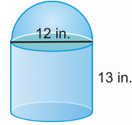

2.
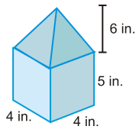

3.
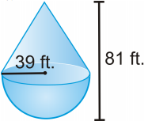

4.
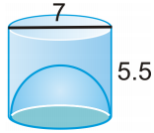
Open hemisphere

5. Tennis balls with a 3 inch diameter are sold in cans of three. The can is a cylinder.
a) What is the volume of one tennis ball?

b) What is the volume of the cylinder?

c) How much space is not occupied by the tennis balls in the can?

6. One hot day at a fair you buy yourself a snow cone. The height of the cone shaped container is 5 in and its radius is 2 in. The shaved ice is perfectly rounded on top forming a hemisphere.
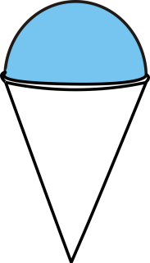
What is the volume of the ice in your frozen treat?

