Name ____________________________________________ Date _________________ Period ______

**Topic:** Volume of Cylinder and Cones  **Website**: msgiwa1.weebly.com

|  |
| --- |
| **Volume of a Prism or Cylinder:** |

Prisms:

1. B = _______, V = _______ 2. B = _______, V = _______

[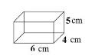](https://www.google.com/url?q=http://www.mathatube.com/geometry-volume-of-a-rectangular-prism.html&sa=U&ei=YTNDU8rNG4-T0gGy54GgDQ&ved=0CD4Q9QEwCA&usg=AFQjCNEVEq1zZLZvW7blz9dRKGD4qx8S8Q) 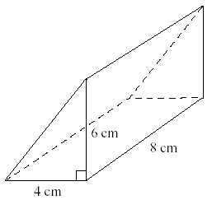

Cylinders:

 3. B = _______, V = _______ 4. B = _______, V = _______



|  |
| --- |
| **Volume of a Cone or Pyramid** |

1. B = ____, V = ____ 6. B = ____, V = ____ 7. B = ____, V = ____

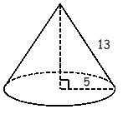

|  |
| --- |
| **Volume of a Sphere** |

Find the volume of the sphere. Round your result to two decimal places.

 8. _______ 9. _______

10. What happens to the Volume of a sphere if you triple the radius?

**Volume of Composite Figures**

11. ________

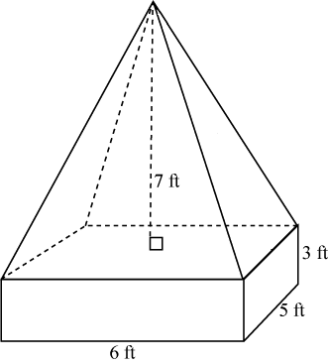

12. _________

