Name ____________________________________________ Date _________________ Period ______

**Topic:** Volume of Prisms and Pyramids  **Website**: msgiwa1.weebly.com

**Find the volume of each of the following and round to the nearest tenth.** 



1. B = _______

V = _______

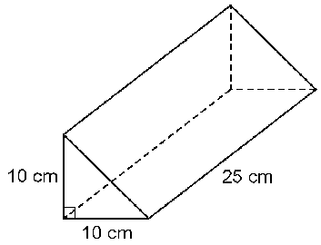

1. B = _______

V = _______

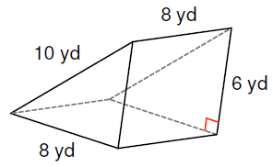

1. B = _______

V = _______

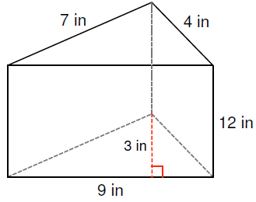

1. B = _______

V = _______



1. B1 = _______ B2 = _______

V1 = _______ V2 = _______

Total V = ________