Name ____________________________________________ Date _________________ Period ______

**Topic:** Circles: Vocabulary & Central Angles **Class Website**: msgiwa1.weebly.com

|  |  |  |
| --- | --- | --- |
| **Part** | **Description** | **Image** |
| **Circle** | The set of all points that are __________________ from a reference point, the _________. The set of points forms a 2-dimensional curve that measures ___. |  |
| **Chord** | A __________________ whose _______________ lie on the circumference of the circle. |  |
| **Diameter** | A straight line passing through the _______ of a circle connecting two points on the circle; equal to ________ the radius. |  |
| **Radius** | The distance from the _______ to a ______ on the circle; equation to _____ the diameter. |  |
| **Secant** | A line that intersects a circle at _____ points. |  |
| **Tangent Line** | A line that intersects a circle at exactly _____ point and is _______________ to the radius of the circle. |  |
| **Point of Tangency** | Where the tangent line ______________ the circle. |  |

|  |  |  |
| --- | --- | --- |
| **Major Arc** | **Semicircle** | **Minor Arc** |
|  |  |  |
| An _______ that is ______ of a circle. | Part of a circle’s circumference that is _______ than its semicircle. | Part of a circle’s circumference that is _______ than its semicircle. |
|  |  |  |

|  |  |  |
| --- | --- | --- |
| **Central Angles** | An angle with its _________ at the __________ of a circle. |  |
| **ANGLE = ARC** |

|  |
| --- |
| **THINGS TO KNOW AND REMEMBER ALWAYS!** |
| * A circle has _______________. * A semicircle has ____________. * Vertical Angles are __________. * Linear Pairs are _____________. |

|  |  |
| --- | --- |
| **Arc Addition Postulate** | **Congruent Arcs** |
|  |  |
|  | Two arces that have the same ______ measurement and are either of the same circle or two congruent circles. |

**Examples**

|  |  |
| --- | --- |
|  |  |

**Name the arc shown in bold and classify it (minor, major, or semi).**

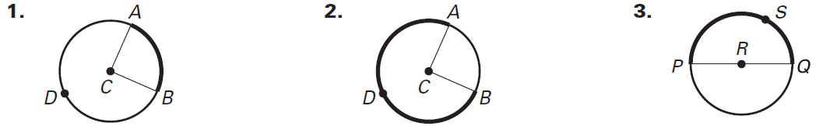

**___________ arc. ___________ arc. ___________ arc.**

**4. Identify and name each of the following frm 🖸O. Be sure to use the correct notation.**

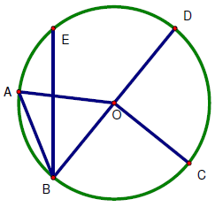

1. Two different central angles: _____, _____
2. Three different minor arcs: _____, _____, _____
3. Three different major arcs: _____, _____, _____
4. A semicircle: _____
5. Two different chords: _____, _____
6. The central angle subtended by : _____

5. = _____ 6. = _____ 7. = _____

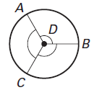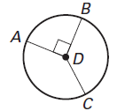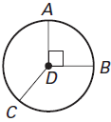

8. = _____ 9. = _____, = _____ 10. = _____, = _____

